Analysis- Excel Home Work

The dataset contains data pertaining to kick starter campaigns that were launched in well known countries of North America and Europe across various categories like Film and video, Food, Games, Photography, Music, Technology, Theater, journalism and publishing during 2009 to 2017. The data also shows when the campaigns were launched, set goals for raised funds, actual amount raised and whether the event was a success or a failure.

Based on the preliminary evaluation of the dataset, following conclusions can be drawn:

1. The campaigns with low goal (in amount) are more likely to be a success than the higher goal campaigns. As the goal increases the probability of failure increases and the event are more likely to get cancelled or are deemed as a failure.

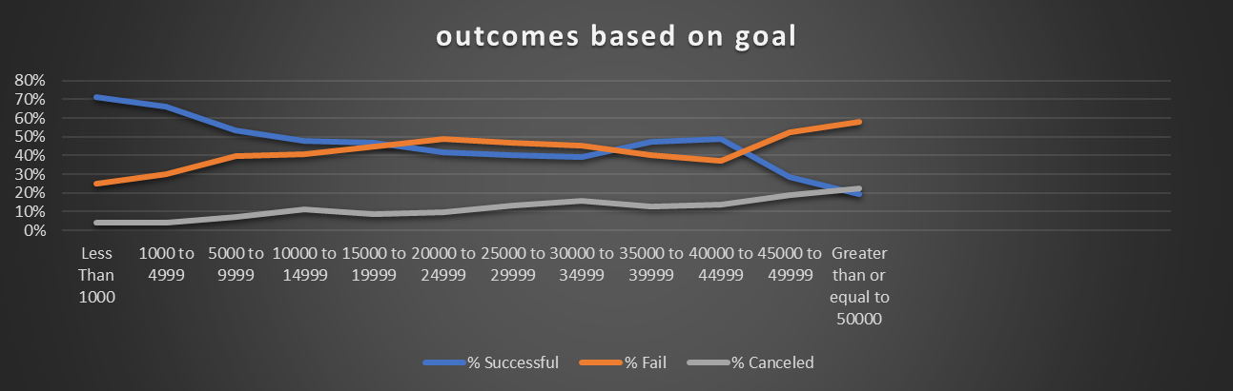

1. Success rate for the campaigns in the Music category is highest followed by Theater. However, Rock music tops the charts in the Music category and Plays in Theater category. (Based on total campaigns in that category)

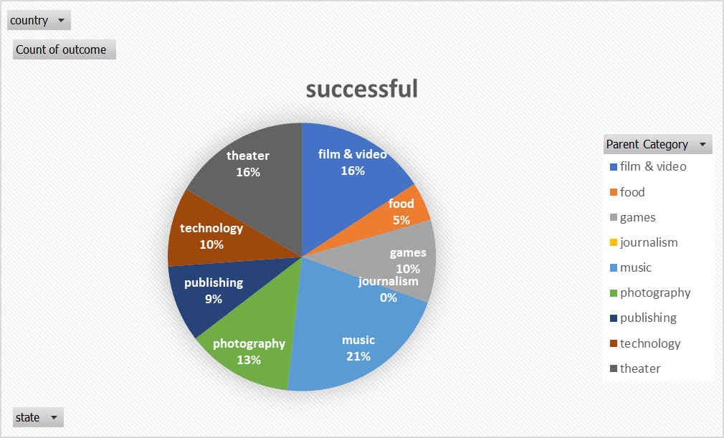

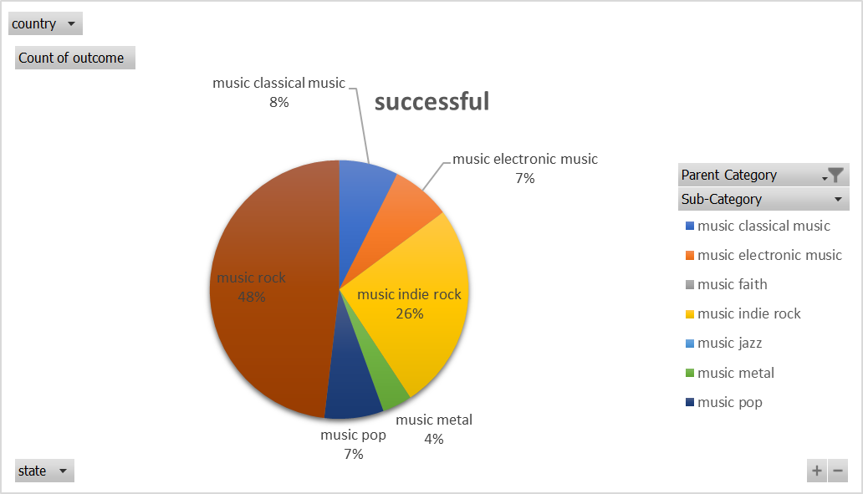

If we look at the successful campaigns only, then the “Theater” category bag the first position.

1. The best time to launch the campaigns comes out to be May, with success rate of 60.6%(of all the campaigns launched in May). The campaigns launched in December are more likely to fail.

This data has certain limitations- it is based on a few well-known countries of North America and Europe. Also, there is no certain way to determine, how the campaign was declared a success or a failure. Further it is very difficult to predict the trends in %funding received per sub-category, ultimately predicting whether new campaign in that category will be a success or failure.

We can further analyze: average donations per category and backer_mumbers to determine which subcategory is more likely to get more backers and more fundings.